**Standard Operating Procedure**

**Loader Operation**



**ODISHA MINING CORPORATION LTD.**

**KODINGAMALI BAUXITE MINE**

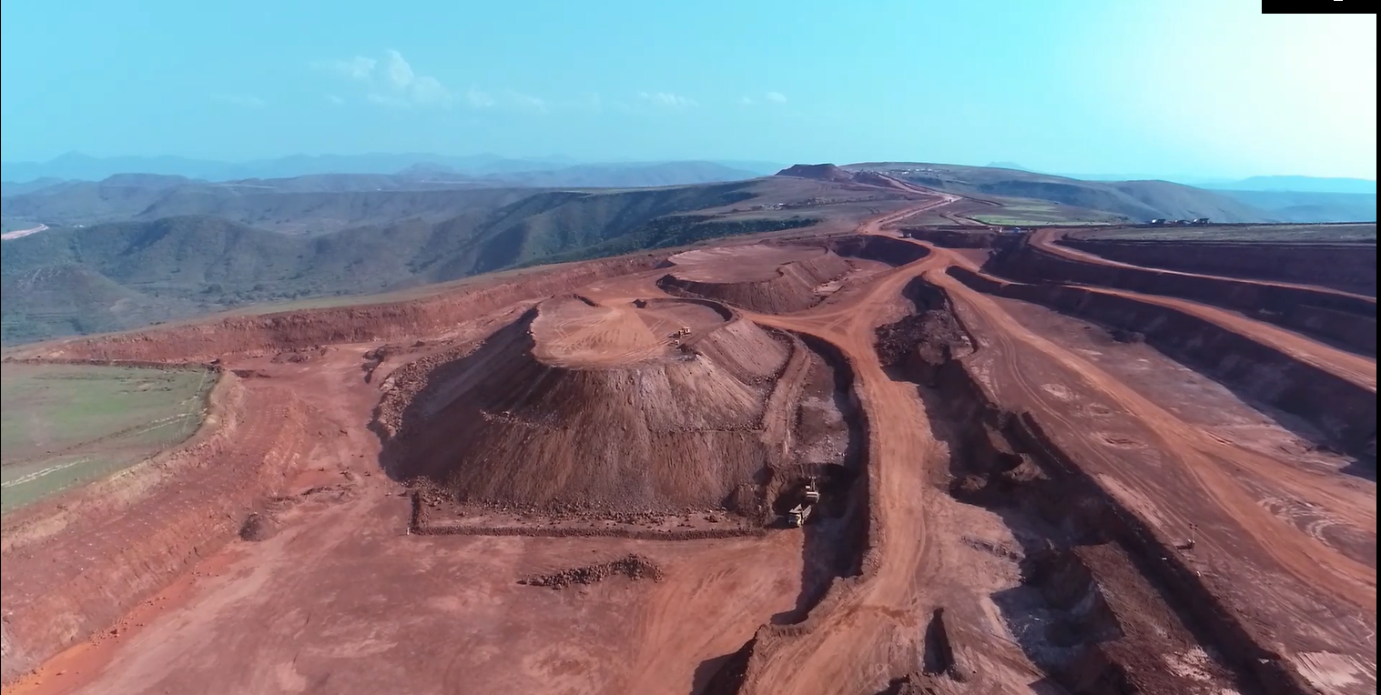

**Authorized By**

1. **Purpose:**  The standard is to establish safe operation with respect to loader in mine site.
2. **Responsibility:**

Mechanical in charge shall be overall in charge to ensure safety of HEMM operating in mines. He shall work along with Shift Incharge, Area Incharge and Safety officer to implement the standard across mine.

Operator shall be responsible to ensure safe operation of vehicle as per standard.

|  |  |
| --- | --- |
| 1. **PPE:** 2. Safety helmet 3. Safety shoe 4. Rubber Gloves 5. Nose Mask 6. Fluorescent jacket 7. Safety goggles. | **Training needs:**   1. Line of Fire 2. Traffic rules and Driving safety 3. Usage of PPEs 4. Fire Safety in HEMM 5. Safety and Health Hazard 6. Loader Operation 7. Loading and Hauling Operation |

1. **Safety and Health Hazard**

* Slip/trip/fall.
* Head on Collision.
* Roll Over/Toppling of water tanker.
* Hitting to other Truck/Structure/Persons.
* Dust generation during Operation.
* Noise during Operation.
* Vibration during Operation.
* Diesel/ Hydraulic Oil - Inflammable, Fire hazards.
* Acid Batteries- Skin contact can lead to extensive and severe burns and highly toxic.

In order to avoid injuries to personal and damage to machinery, the following precautions are very important.

* Work required PPE i.e. with safety shoes, helmet, dust musk, fluorescent jacket suitable for long distance visibility etc.
* Pre Operation Safety features checklist.
* Regular Checks & Maintenance.
* Use seat belt while driving.

1. **Procedure:**
2. Loader operators has to conducted full check up of safety devices & other parameters of his allocated loader and he is determined that it is functioning in order / it is in safe working / serviceable condition.

Safety devices like:-

1. Brakes
2. Head Lights
3. Horns
4. Emergency brakes
5. Back Alarms
6. Blinkers
7. Level of Fuel / quantity of Fuel
8. Level of Lubricating
9. Level of hydraulic transmission
10. Level / quantity of brake oil
11. Level of coolant & its quality
12. Fan belt / Dynamo
13. All pressure parameter
14. All Temperature Parameter
15. Tire and tire –pressure
16. Rear view mirror
17. Loader operators are responsible for reporting any unsafe conditions to his supervisor
18. Problem with Loader
19. While operating Loader , he will ensure that :--
20. Loader operators follows speed limit (permissible to Mines / Mines premises).
21. Loader operators adopts safe / economic movement path for loading like:-
    1. Makes tight V-path pattern between the material, his pivot point and the truck/dumper in which material is to be loaded. His tries should rotate no more than One to 1.5 times in both direction- as shorter as better. Experience operator often at ¾ to ¼ tire revolution.
    2. Works left to right to create a pocket for the truck /dumper to back into a 45 degree angle
    3. Parallel Dig: - Sometimes there are situations where it is difficult for loader operator to work left to right. In these cases it is best to perform parallel digs, which runs right to left .the dig face is narrow.
    4. In parallel dig , there is usually no pocket, so position the vehicle ( truck /dumper ) at 15 degree to 20 degree from perpendicular . That set up the V- pattern for the loader.
22. Loader operators will give always signals (horn with blinking light) while he moves forward or backward motion / unloading material and will insure that there is no man or any hindrances in path.
23. Loader operators will always try to load material with full bucket and or as per instruction(s) of the authority with respect of types of material / product.
24. While Loader operators uses loader as a material feeding to Screen , he will ensure that front wheel is not crossed the safe zone.
25. While Loader operators shifts / marches loader from one area to another area and if sight is intersected he uses horns to alert traffic coming from other side.
26. While negotiating curve during shifting /marching the loader, he keeps low speed and select turning radius commensurate with the speed.
27. While in operation he ensures that the gear is selected according to load , gradient and speed .
28. While operates in down gradient he keeps the Loader in low gear range and keeps applying retarders to avid engine over race and consequent damage.
29. He will ensure he has set safety belt his back while drives.
30. Takes special care about children, senior citizen and pedestrian while driving outside of mines /public road.
31. Always observe and anticipate other road users while drives on road.
32. Always wear helmet & seal belts.
33. While driving in mines / mines premises for loader shifting /marching to another working area and or driving on road other than mine- he will follow traffic rules / signals.
34. Obeys instruction(s) of Supervisors / Superiors Operator will ensure that he does not delay deliberately while he loads material or does any other work.
35. Operator will ensure that he gives proper signal (Horns) to the loaded vehicle for proceeding to destination.
36. Operator will ensure that he loads desired quantity of asked material while he works for material dispatch. He tries to give load nearer to asked quantity (not to very high not to very less) .Very high or very low both will reduce productivity.
37. Operator performs all jobs as detailed in Job description for his categories
38. Operator carries over all responsibilities mentioned in job description for his categories.
39. **For Safe Operation at Worksite**
40. Before starting operations, thoroughly check the area for any unusual conditions that could be dangerous.
41. When carrying out operations near combustible materials such as thatched roofs, dry leaves or dry grass, there is a hazard of fire, so be careful when operating.
42. Check the terrain and condition of the ground at the worksite, and determine the safest method of operation. Do not operate where there is a hazard of landslides or falling rocks.
43. If water lines, gas lines, or high-voltage electrical lines may be buried under the worksite, contact each utility and identify their locations. Be careful not to sever or damage any of these lines.
44. Take necessary measures to prevent any unauthorized person from entering the operating area.
45. In particular, if you need to operate on a road, protect pedestrian and cars by designating a person for worksite traffic duty or by installing fences around the worksite.
46. When traveling or operating in shallow water or on soft ground, check the shape and condition of the bedrock, and the depth and speed of flow of the water before starting operations.
47. In order that travel operations can be carried out safely, always keep the roads on the jobsite properly maintained.
48. **Working On Loose Ground**

Avoid traveling or operating your machine too close to the edge of cliffs, overhangs, and deep ditches. The ground may be weak in such areas. If the ground should collapse under the weight or vibration of the machine, there is a hazard that the machine may fall or tip over. Remember that the soil after heavy rain or blasting or after earthquakes is weak in these areas. When working on embankments or near excavated ditches, there is a hazard that the weight and vibration of the machine will cause the soil to collapse. Before starting operations, take steps to ensure that the ground is safe and to prevent the machine from rolling over or falling.

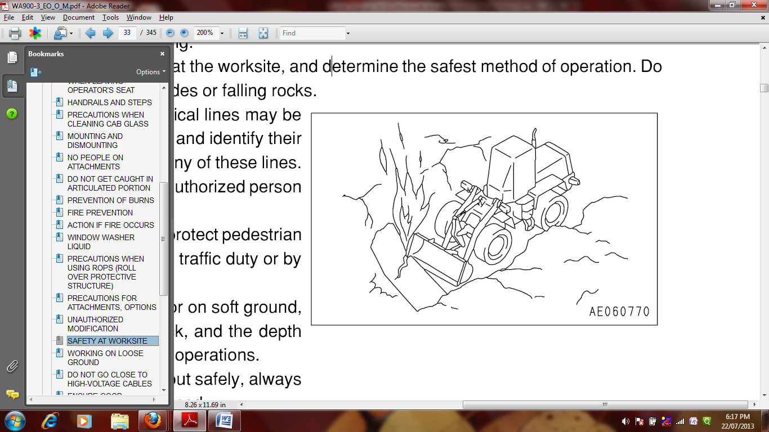

1. **Precautions For Operation**
2. **Starting Engine**
3. If there is a warning tag hanging from the work equipment control

Lever, do not start the engine or touch the levers (1).

1. **Checks Before Starting Engine**
2. Carry out the following checks before starting the engine at the beginning of the day's work.
3. Remove all dirt from the surface of the window glass to ensure a good view.
4. Remove all dirt from the surface of the lens of the front lamps, working lamps, and rear combination lamp, and check that they light up correctly.
5. Check the coolant level, fuel level, and oil level in engine oil pan, check for clogging of the air cleaner, and check for damage to the electric wiring.
6. Check that there is no mud or dust accumulated around the movable parts of the accelerator pedal or brake pedal, and check that the pedals work properly. Adjust the operator's seat to a position where it is easy to carry out operations, and check that there is no damage or wear to the seat belt or mounting clamps.
7. Check the operation of the instruments and gauges, check the angle of the mirror, and check that the control levers are all at the Neutral position. Before starting the engine, make sure that the work equipment lock lever is in the LOCK position. Adjust the mirrors so that the rear of the machine can be seen clearly from the operator's seat. See "ADJUSTING MIRRORS (PAGE 3-84)".
8. Check that there are no persons or obstacles above, below, or in the area around the machine.
9. **Precautions when starting**
10. Start and operate the machine only while seated.
11. Do not attempt to start the engine by short-circuiting the engine starting circuit. Such an act may cause a serious bodily injury or fire. When starting the engine, sound the horn as a warning. Do not allow anyone apart from the operator to ride on the machine. For machines equipped with a back-up alarm, check that the alarm works properly.
12. **Operation checks before operation**
13. When carrying out the checks, move the machine to a wide area where there are no obstructions, and operate slowly. Do not allow anyone near the machine. Always fasten your seat belt.
14. Check the operation of travel, steering and brake systems, and work equipment control system.
15. Check for any problem in the sound of the machine, vibration, heat, smell, or gauges; check also that there is no leakage of oil or fuel. If any problem is found, carry out repairs immediately. Before driving the machine or starting operations, check that
16. Frame lock bar (1) is securely fixed at the FREE position.
17. **Precautions when traveling in forward or reverse**
18. Before travelling, check again that there is no one in the surrounding area, and that there are no obstacles.
19. Before travelling, sound the horn to warn people in the area.
20. Always operate the machine only when seated. Do not allows anyone apart from the operator to ride on the machine.
21. Check that the backup alarm (alarm buzzer when machine travels in reverse) works properly. Lock the cab door and windows securely, both when they are open and when they are closed. If there is an area to the rear of the machine which cannot be seen, position a signal person. Take special care not to hit other machines or people when turning or swinging the machine. Always be sure to carry out the above precautions even when the machine is equipped with mirrors.

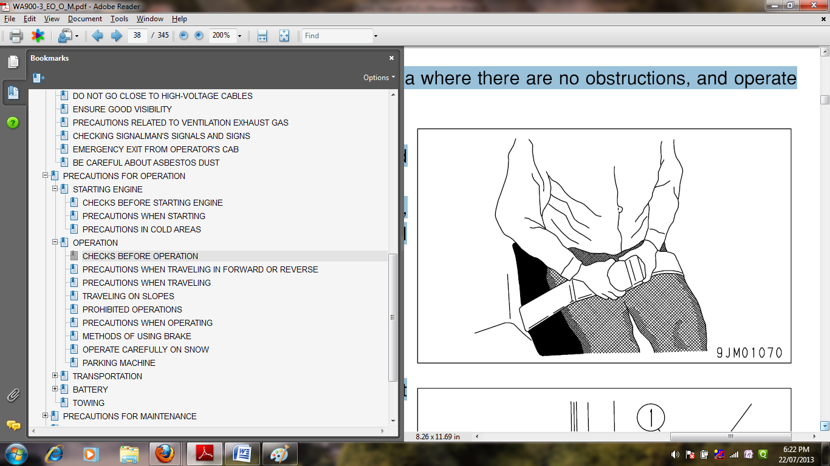

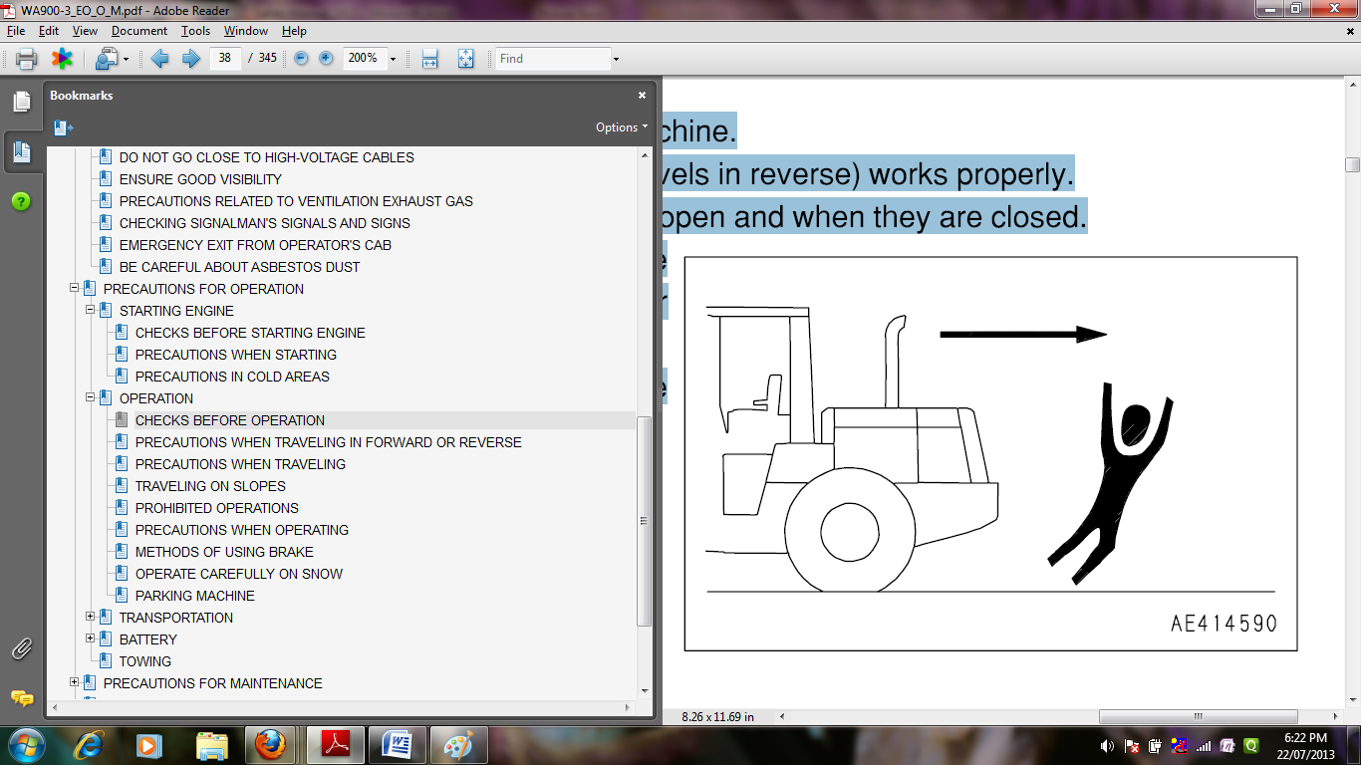

1. **Precautions when traveling**
2. Never turn the key in the starting switch to the OFF position. It is dangerous if the engine stops when the machine is traveling, because it becomes impossible to operate the steering. If the engine stops, depress the brake pedal immediately to stop the machine.
3. When traveling on flat ground, keep the work equipment at height (A) of 70 - 90cm (2ft 4in - 2ft 11in) above the ground surface. If it is necessary to operate the work equipment control lever, stop the machine, then operate the lever.
4. When traveling on rough ground, travel at low speed and do not operate the steering suddenly. There is danger that the machine may turn over. The work equipment may hit the ground surface and cause the machine to lose its balance, or may damage the machine or structures in the area.
5. Avoid traveling over obstacles when possible. If the machine has to travel over an obstacle, keep the work equipment close to the ground and travel at low speed. Never travel over obstacles which make the machine tilt strongly to one side.
6. When traveling or carrying out operations, always keep a safe distance from people, structures, or other machines to avoid coming into contact with them.
7. When passing over bridges or structures, check first that the structure is strong enough to support the mass of the machine.
8. When operating in tunnels, under bridges, under electric wires, or other places where the height is limited, operate slowly and be extremely careful not to let the work equipment hit anything.
9. If you drive the machine at high speed continuously for a long time, the tires will overheat and the internal pressure will become abnormally high. This may cause the tires to burst. If a tire bursts, it produces an extremely large destructive force, and this may cause serious injury or accident.
10. If you are going to travel continuously, please consult your Komatsu distributor.
11. **Traveling on slopes**
12. To prevent the machine from tipping over or slipping to the side, always do as follows.
13. Keep the work equipment at height (A) (70 - 90 cm (2ft 7in - 2ft 11in) above the ground) so that it can be lowered immediately to the ground to stop the machine in case of emergency.
14. Always travel straight up or down a slope. Traveling at an angle or across the slope is extremely dangerous. Do not turn on slopes or travel across slopes. Always go down to a flat place to change the position of the machine, then travel on to the slope again.
15. Travel on grass, fallen leaves, or wet steel plates with low speed. Even with slight slopes there is a hazard that the machine may slip. If the engine stops, depress the brake pedal immediately, lower the bucket to the ground, and apply the parking brake to stop the machine.
16. When traveling downhill, never shift gear or place the transmission at neutral. It is dangerous not to use the braking force of the engine. Always place the transmission in a low gear before starting to travel downhill.
17. When traveling downhill, travel slowly. If necessary, use the braking force of the engine together with the brake pedal to control the travel speed.
18. When traveling up or down hills with a loaded bucket, always travel with the bucket facing uphill. If the machine travels with the bucket facing downhill, there is danger that the machine may tip over.

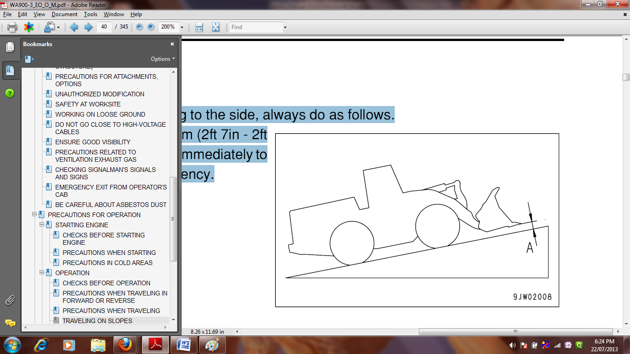

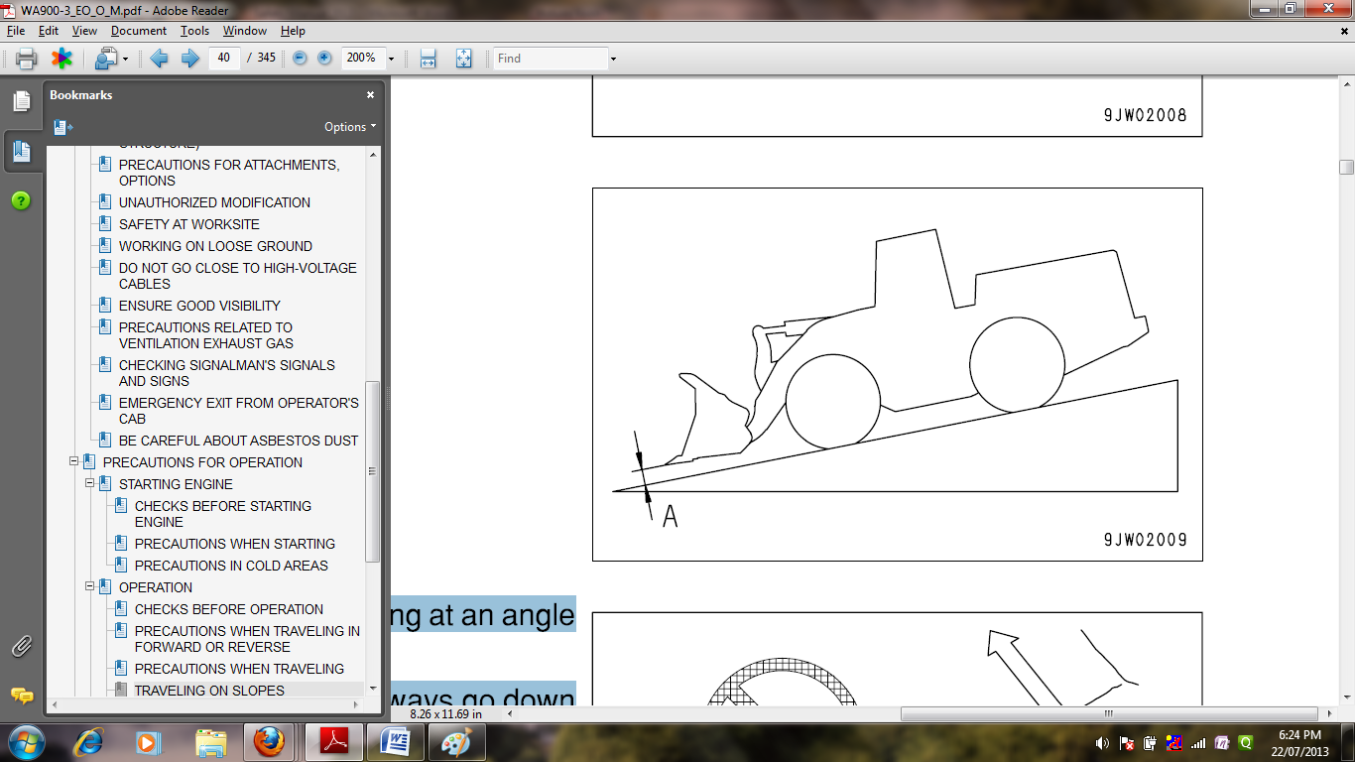

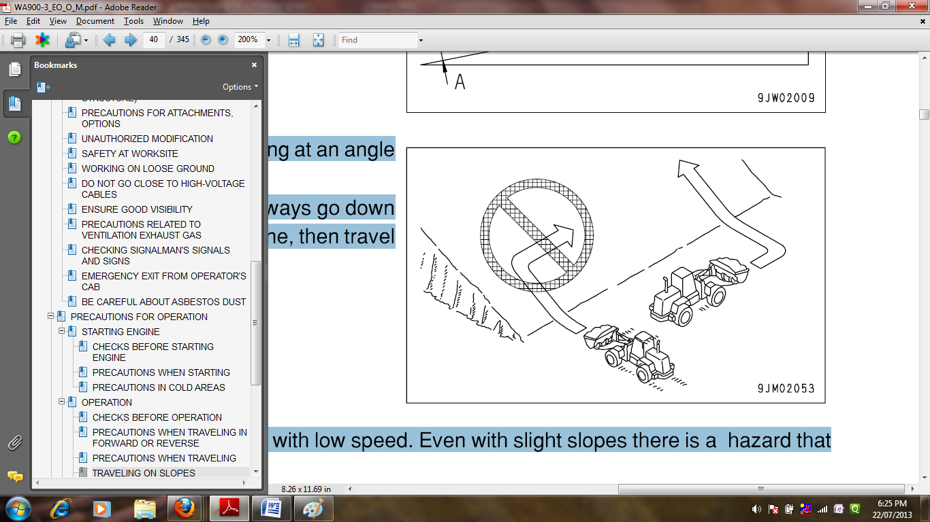

1. **Prohibited operations**

It is dangerous to excavate the bottom of a rock face. Never do this. When digging, never thrust the bucket into a load at an angle. This will bring an excessive load to bear on the machine and will reduce the service life of the machine.

It is dangerous to apply drive force when excavating a rock face. In addition, an excessive load will be brought to bear on the machine and this will cause damage to the machine. Never carry out digging operations on a downhill slope. An excessive load will be brought to bear on the machine and this will cause damage to the machine. It is dangerous to use the bucket or lift arm for crane operations, so do not carry out such operations. Do not pass the bucket over the head of other workers or over the operator's seat of dump trucks or other hauling equipment. The load may spill or the bucket may hit the dump truck and cause serious injury or property damage.

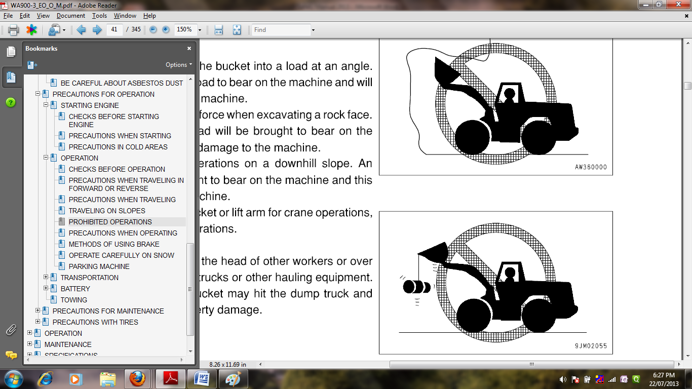

1. **Precautions when operating**
2. When using the machine, to prevent the machine from overturning due to overloading and to avoid damage to the work equipment, do not exceed the maximum permitted load or performance of the machine.
3. If the engine cannot be started again after it has stopped, immediately operate the work equipment control levers to lower the work equipment to the ground. (After the engine stops, the accumulator allows the work equipment to be operated for a limited time.)
4. Be careful not to approach too close to the edge of cliffs. When making embankments or landfills, or when dropping soil over a cliff, dump one pile, then use the next pile of soil to push the first pile.
5. The load suddenly becomes lighter when the soil is pushed over a cliff or when the machine reaches the top of a slope. When this happens, there is danger that the travel speed will suddenly increase, so be sure to reduce the speed.
6. When the bucket is fully loaded, never start, turn, or stop the machine suddenly. There is danger of the machine turning over. When handling unstable loads, such as round or cylindrical objects, or piled sheets, if the work equipment is raised high, there is danger that the load may fall on top of the operator' compartment and cause serious injury or damage.
7. When handling unstable loads, be careful not to raise the work equipment too high or tip the bucket back too much. If the work equipment is suddenly lowered or suddenly stopped, the reaction may cause the machine to tip over. Particularly when carrying a load, be sure to operate the work equipment carefully.
8. When operating in tunnels, under bridges, under electric wires, or other places where the height is limited, be extremely careful not to let the work equipment hit anything.
9. To prevent accidents caused by hitting other objects, always operate the machine at a speed which is safe for operation, particular in confined spaces, indoors, and in places where there are other machines.

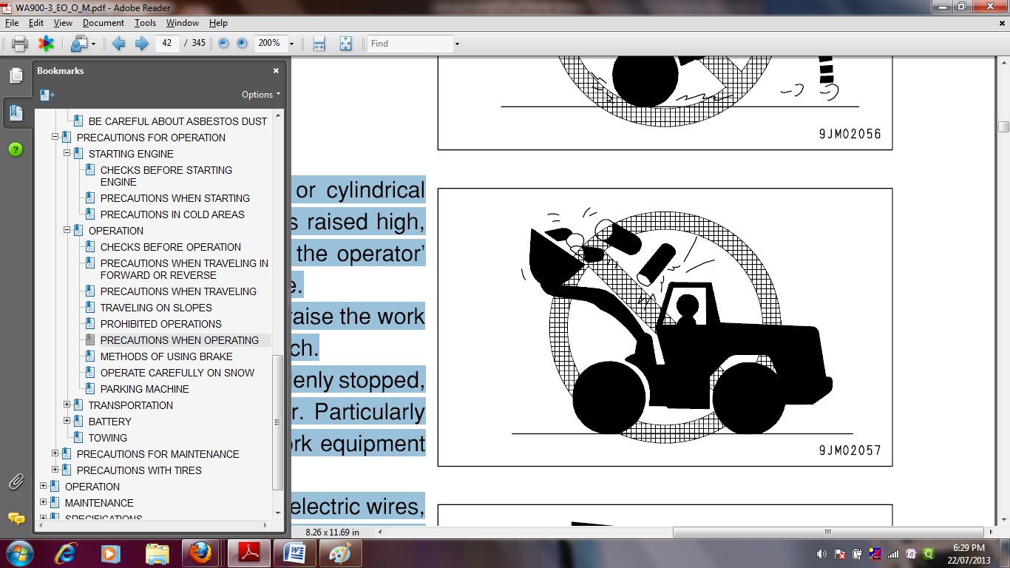

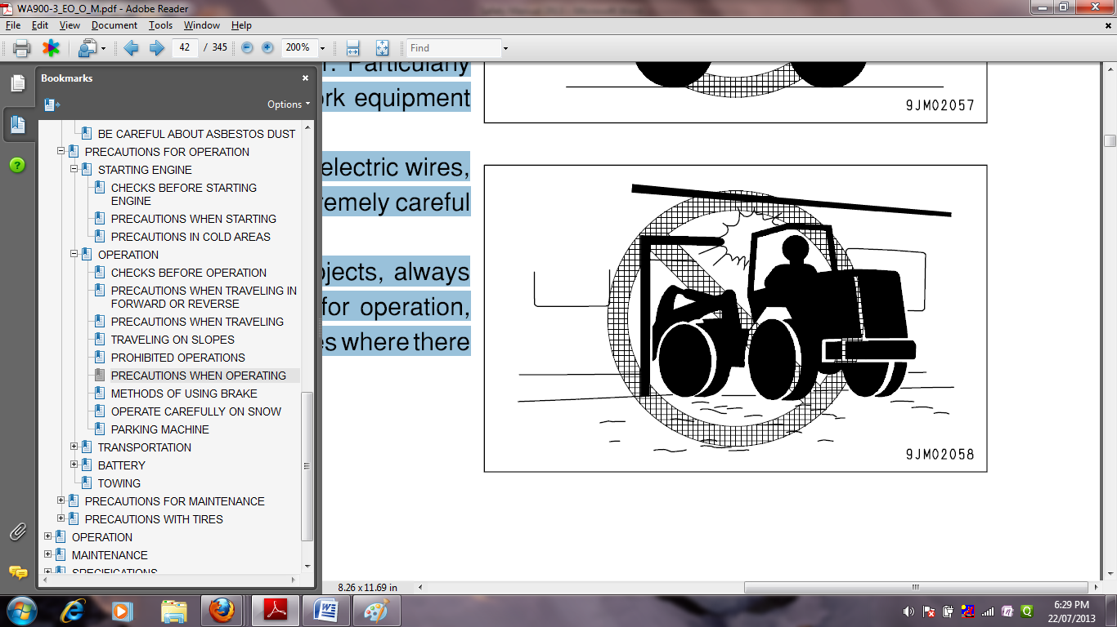

1. **Battery hazard prevention**
2. Battery electrolyte contains sulphuric acid, and batteries generate flammable hydrogen gas, which may explode. Mistaken handling can lead to serious injury or fire. For this reason, always observe the following precautions.
3. Do not use or charge the battery if the level of the battery electrolyte is below the lower level. This may cause an explosion. Always inspect the battery electrolyte level periodically and add distilled water to the upper level.
4. When working with batteries, always wear safety glasses and rubber gloves.
5. Never smoke or use any flame near the battery. If you spill acid on your clothes or skin, immediately flush the area with large amount of water. If acid gets into your eyes, flush them immediately with large amount of water and seek medical attention.
6. Before working with batteries, turn the starting switch to the OFF position. As there is a hazard that sparks will be generated, always do as follows. Do not let tools or other metal objects make any contact between the battery terminals. Do not leave tools or other metal objects lying around near the battery.
7. Always disconnect the negative (-) terminal (ground side) first when removing the battery; when installing the battery, connect the positive (+) terminal first, and connect the ground last. Tighten the battery terminals securely. Flammable hydrogen gas is generated when the battery is charged, so remove the battery from the chassis, take it to a well-ventilated place, and remove the battery caps before charging it. Tighten the battery caps securely. Install the battery securely to the determined place.

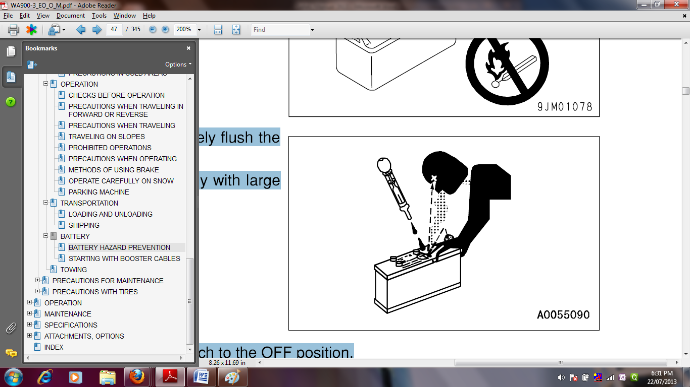

1. **Precautions with tires handling tires**
2. If tires or rims are handled mistakenly, there is danger that the tire may explode or be damaged, or that the rim may fly off and cause serious injury or death. To maintain safety, always do as follows. Maintenance, disassembly, repair, and assembly of the tires and rims requires special equipment and special technology, so always ask your Komatsu distributor to carry out these operations.
3. Always use the tires specified by Komatsu and maintain the specified inflation pressure.
4. Suitable tire inflation pressure: see "HANDLING THE TIRES (PAGE 3-141)"
5. When pumping up the tires, check that no other person is standing near the tire, and install an air chuck with a clip that can be secured to the air valve.
6. To prevent the tire inflation pressure from becoming too high, measure the pressure from time to time with an air gauge while pumping up the tire. If the tire pressure goes down abnormally or the rim parts do not fit the tire, there is a problem with the tire or rim parts. Always contact your Komatsu distributor for repairs. If the rim parts are not fitted properly when the tire is being pumped up, there is danger that the rim parts may fly off, so set up a protective fence around the tire, and do not stand directly in front of the rim. Stand beside the tread when pumping up the tire.
7. Do not adjust the tire inflation pressure immediately after traveling at high speed or carrying out operations under heavy load. Never carry out welding or light a fire near the tire.

